Stock Market Movement Prediction using Sentiment Analysis and Time Series Forecasting

Umang Gupta
Student
CSE Department
NIT Trichy
Trichy, India
106114098@nitt.edu
Adiki Srichakra
Student
CSE Department
NIT Trichy
Trichy, India
106114005@nitt.edu
S Jaya Nirmala
Assistant Professor
CSE Department
NIT Trichy
Trichy, India
sjaya@nitt.edu
Akshay Aravindh
Student
CSE Department
NIT Trichy
Trichy, India
akshay.aravindh1015@gmail.com

Abstract—Today, the stock market is attracting a lot of attention from various big Investment firms through its high-level risks and the high returns involved with it. Stock Exchange markets typically involve securities investments like NYSE, NSE, DJIA, etc. that are advantageous to the global economy. A novel approach for prediction of Stock Market fluctuations is introduced through opinion mining by classification of sentiments of Twitter messages related to that stock. Healthcare industries like Apple Inc were focused. Other industries related to technology and other fields can also be used in the proposed approach. The future stock returns like Closing Price and Daily Change, have some predictive properties with respect to publicly available information of present sentiments on Social Media like Twitter and historical stock market datasets on NASDAQ, Yahoo! Finance, or Google Finance. A prediction model based on the analytics for forecasting the movements of Stock markets for next day is proposed in this paper through NLP and time series forecasting for a short-term prediction like ARIMA model and Neural Network for finding hidden states. It will help in automating the forecasting of stock price movements in future and gives a helping hand for global financiers, angel investors and investment bankers to decide the right time for selling and purchasing of stocks in correlation with public sentiments. The results are shown in terms of sentiment analysis outputs and visualizations using R, Python, Java, and Hadoop. The correlations and forecasts obtained conclude the proposed model’s good potential for prediction of stock market movements on a short-term basis and consistent with public sentiments.
Keywords— Time Series Forecasting, Stock Market Investment Strategies, Prediction Algorithms, Big Data Analysis, ARIMA Neural Network, Random Walk, Ensemble Model, Distant Supervision Learning, Twitter Sentiment Opinion Mining

Introduction
In financial stock markets, it is considered to be an impossible task to predict most-likely stock market movement. There are generally two approaches for predicting the future market movements. One approach [1] relates to Analysis of current sentiments related to a firm like that of Apple Inc. from social media and news. The other approach [7] involves using Time Series Forecasting methods on previous historical data to find patterns in short-term seasonal intervals predict the most likely bounded price change and its accuracy.
In the first approach of the proposed model, big data from social media sites like Twitter is used for analysis. Positive and negative sentiments are identified for companies using Natural Language Processing through word dictionaries and n-grams model. Public sentiments and opinions regarding Financial data news and currents events in Twitter are also streaming at an exceptional speed that must be dealt with in a well-timed manner to get the present thoughts of people regarding the Firm and its stocks and securities, which has also attracted the attention of a lot of researchers. When someone buys a stock, he/she generally buys it because of something he/she heard about on the news, social media or through their friends. This external information is used for stock market prediction. Based on this a correlation is found between Daily Price Change and sentiment score to predict next day's most likely movement.
For the second approach, Historical stock market changes dataset is used for forecasting by assuming that certain patterns have bearings on the future for short-term linear intervals. This is what the ARIMA prediction model for time series forecasting is based on and is famous for. Another challenging approach to ARIMA assumes using Historical data as it is like a random series and use it for short-term forecasting. This is the basis for another popular model known as Random Walk. These approaches can be combined with the prediction of Stock returns to uncover market patterns, plan strategies for future investments, and forecast the value of next day's closing price.

Related Works

The most popular research published in prediction through sentiment analysis area is by Bollen’s [2] thorough investigation of the public sentiments into 6 dimensions of anxiousness, calmness, vitalness, kindness, sureness, and happiness obtained from feeds of Twitter data and its correlation with the Dow Jones Industrial Average (DJIA) Index values, found through usage of a Fuzzy Neural Network and Granger Causality Analysis for predicting and proving the existing correlation with an accuracy of 86.7 percent in market movements and closing values with very low MAPE (Mean Average Percentage Error). Chen and Lazer [8] built a prediction model to derive the investment strategies through the observation and classification of the twitter feeds into Financial positive and negative sentiments. On the basis of industry type in which people work, Bing et al. [9] studied twitter dataset to predict prices of stock markets. Some of the industries they used were Technology, Finance, Information Technology, etc. A strong negative correlation pattern was found out by Zhang [10], between public opinions of worriedness, fearfulness, and hopefulness in tweets and values of DJIA indices. A research in this field was also done by Brian et al. [11] recently, based on the correlation of stock price rise and fall with the public sentiments through the study of Pearson correlation coefficient for stocks. In a paper of Mittal et al. [12], it was proven that the mechanism of predicting with accuracy rate to be around 75 percent with a usage Fuzzy neural networks on DJIA Index and Twitter Feeds.
Research in the prediction of Stock Markets has also been done with help of algorithms in Artificial Intelligence field by Bouktif et al. [17]. They combined Bayesian Classifiers with the Ant Colony Optimization algorithm on the public mood states obtained from Twitter giving a significant performance in prediction accuracy of concerned stock values. The approach related to Time series forecasting has also been researched through Deep Neural Networks by Gunduz et al. [18]. Convolutional Neural Network was used for prediction of the direction of movement of the closing price of GARAN, THYAO and ISCTR stocks. LSTM Neural Networks were also used in time series forecasts by Nelson et al. [20] for predicting future trends in the market through stock price history and analysis indicators with 56 percent accuracy of movement direction were found. An Ensemble model of forecasting has been studied by Bautu et al. [19] by ensembles of Gene Expression Programming (GEP) evolved models in deep learning and artificial intelligence fields through binary classification of stock prices. ARIMA model (Auto-Regressive Integrated Moving Average) was studied for forecasting in R by Angadi et al. [7] in depth and was found to be very accurate for short-term forecasting of stock market trends. EMMS (Expert Model Mining System) combining AR (Auto-Regression), I (Integration), MA (Moving Average) with ES (Exponential Smoothening) was researched by Rao et al. [1] reducing MAPE by combining it with social media Sentiment Analysis Correlations for NASDAQ (National Association of Securities Dealers Automated Quotations) and DJIA values with 75.56 percent accuracy through learning algorithms of Support Vector Machines and Neural Networks for Portfolio Management implemented in MATLAB software.

Proposed Sentiment Analysis Methodology

Twitter Sentiment Lexical Analytics
Sentiment analysis involves usage of NLP and computational linguistics is involved in this domain to preprocess data through cleaning, removing redundancy, converting encodings, textual analysis, etc., along with the extraction of knowledge in the sources like positive and negative opinions. It is also referred to as opinion mining in the field of Natural Language Processing. Sentiments are defined to be awesome, very good, good, neutral, bad and poor/very negative feeling in this proposed research project work.
Twitter feed is a social media platform used online for sharing recent news through the usage of “tweets”. More than a billion users are responsible for sending and reading of these “tweets”, which are short 140-character messages. Hence Twitter is a public platform with a mine of public opinion of people all over the world and of all age categories. In Twitter Sentiment Analysis, the emotional tone of people behind a series of word sets inside a particular tweet is determined, to gain an understanding of the feelings, sentiments, and emotions expressed through an online hashtag/mention/reference of the stocks related to technology giant Apple Inc., USA.

Through Positive and Negative Word Corpus Dictionaries for unigrams and bigrams
Data is extracted using Twitter Feed API. The 9,000 tweets are collected, preprocessed, cleaned and filtered by performing sentiment analysis using R programming. A large number of analysts and researchers make use of R language to take care of most difficult problems in the fields ranging from computational science and big data analytics to quantitative promoting, natural language processing and opinion mining.
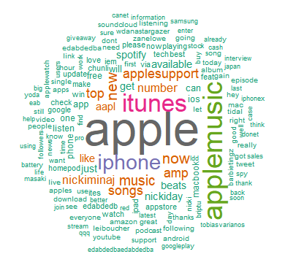
Fig.1. Word Cloud of Apple Inc.
Tweets are the best example of Unstructured Data with high velocity and variety. They generally consist of a lot of symbols, hashtags, shorthand notations, emojis, annotations, MAC encodings and unnecessary information like images, videos and URL links. Some tweets could also be retweeted multiple times by others creating redundancy. So the tweets are preprocessed and filtered to represent correct public opinions, emotions, feelings, and sentiments. For tweet preprocessing, multiple levels of extraction like corpus formation, obtaining a stream of tokens, and stop words removal, and conversion to ASCII encodings for removing special characters were used to filter the right data. After this, the word corpus of tweets is ready for opinion analysis. From this word corpus, frequent words used in the sentiments are filtered and show in the form of word cloud [Fig. 1.], which can be used for outlier and robot analysis along with the list of people responsible for these sentiments.
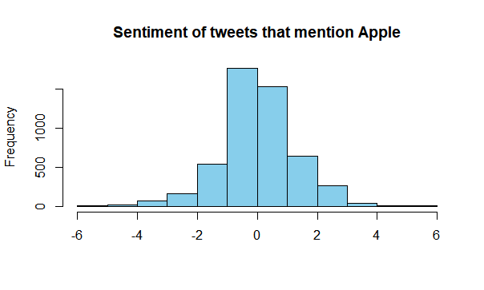
Fig.2. Histogram for Sentiment Analysis of Tweets that mention Apple Inc.
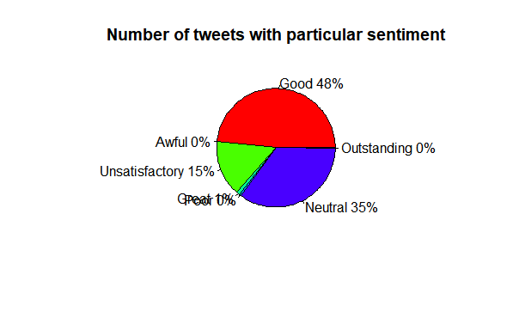
Fig.3. Pie Chart for Apple Inc.’s Sentiment Distribution
Tweets are classified as "positive" like awesome, very good, good; "neutral" like neutral/average/normal; "negative" like bad, poor/very negative feeling [Fig. 3.], based on the scores calculated through a function on the sentiments present in the corresponding tweets. From this frequency of tweets for each sentiment can be aggregated in a Histogram [Fig. 2.]. Positive and Negative words dictionary obtained from research work of Bing Liu et al. [5] were used. To improve the accuracy of the dictionary, the list of positive words developed from the research work done by Positive Words Research [13] containing more than 6500 positive words, phrases, and quotes, thereby making it the largest list of positive sentiments expressed in the English language all over the world were added. This sentiment words list has positive adjectives, verbs, adverbs, nouns, pragmatics, discourse and interjections, phrases, inspirational quotes and idioms, words of encouragement, and sayings, positive expressions, ideology and thinking, sentences in the English language spoken globally.
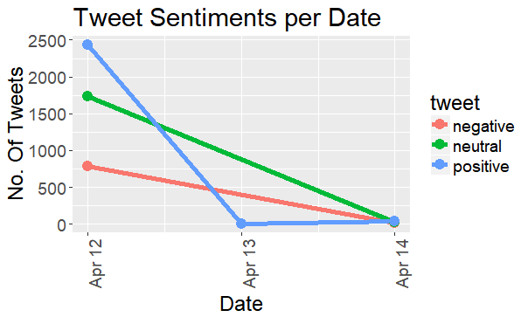
Fig.3. Sentiment distribution of Apple Inc. over time.

Machine Learning through Support Vector Machines for morphological understanding
Machine Learning model was used for efficiency in detecting sarcasm and fake sentiments. Support Vector Machines were used for training of more than 20,000 tweets with an extended search of 280 characters. A JSON file was used for storage of these tweets along with their properties for data preprocessing. The tweets were trained for analyzing sentiment through Python NLP package. Before training, the word tokens were broken down to their respective root words for more accuracy as part of morphology process in NLP. The correlation is found between stock prices and sentiments related to Ticker symbol - "AAPL", for getting all opinions related to the financial area of Apple Inc.’s Stock Exchange. The prediction accuracy of the model was near 90 percent which was used to forecast closing price.

Distant Supervision Learning
Distant Supervised Learning is done through sentiment140 project from a research paper of Stanford University MS graduate students [4] using 1.6 million tweets. The machine learning classifiers used in the module are Maximum Entropy (MaxEnt), Naive Bayes, and Support Vector Machines (SVMs). Feature extractors involved from n-grams were unigrams, bigrams, a combination of unigrams and bigrams, and unigrams with Part of Speech (POS) tags. Emoticons were used as noisy labels for training data to perform distant supervised learning on Twitter data corpus. It was found that combination of above Machine learning algorithms can achieve very high accuracy for classifying opinion sentiments of the public when using this method. This model was accessed through Cloud processing with help of an open-source R package created by the authors which has sentiment module function of sentiment140 model. This is merged with sentiment score function with appropriate weightage to give correlations with Daily Stock Changes [Fig. 4.].

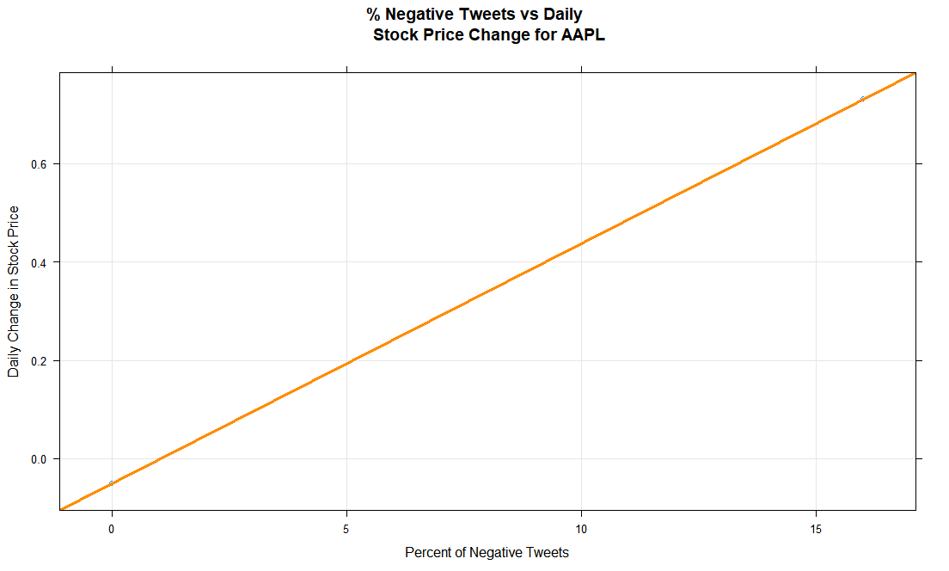
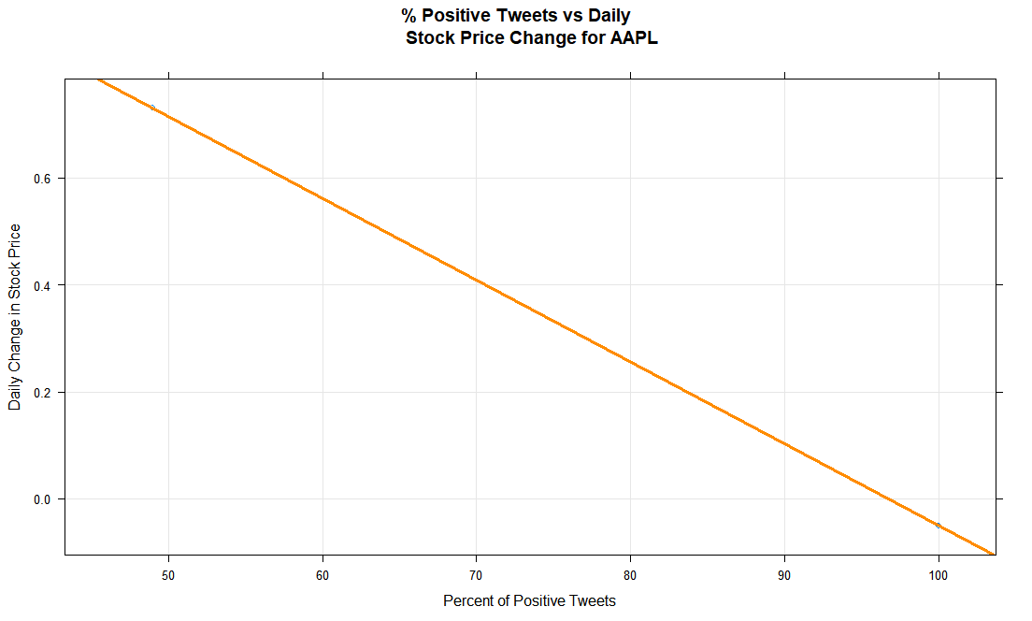
Fig.4. Correlation of negative and positive tweets with Daily Stock price change for Apple Inc.

Historical Stock Datasets

Popular sites like Yahoo! News [16] & Google news [15] have large chunks of research data which try to predict the stock market in real time. Before going into their details, the difference between DJIA and NASDAQ [14] is mentioned herewith. The latter has security stocks which former doesn’t have and also has a large no of companies registered with it.

NASDAQ Historical Securities Stock Quote
Real-time market information and analysis of stock quotes, financials, company news, along with investing tools are featured on the Nasdaq Stock Market website. This API was used to load Apple Inc.’s Historical Quote of past 10 years for sentiment analysis in R. The CSV file [14] was joined with sentiment scores to predict correlation.

Yahoo! Finance NYSE/NSE Quote
Yahoo! Finance features historical data including stock quotes, financial news, and reports. The use cases of the API with respect to Apple Inc. [16] were-

Apple Inc.’s NYSE Quotes were loaded in Support Vector Machine in Python for sentiment based prediction through Machine Learning.

API was used for giving past 6 years stock details of Apple Inc. for probabilistic Time-Series logistic regression based forecasting in Ensemble model of ARIMA and Neural Network models in R-Studio.

MapReduce on Hadoop framework is used to find the most likely percentage change occurring daily in a Random Walk model. Past 40 years dataset was loaded in Hadoop cluster.

Proposed Closing Price Prediction

On the basis of Sentiment correlation of Daily stock price, the convergence region of sentiment analysis was predicted. Then the sentiment distribution was used to know whether to follow positive or negative correlation.

Hidden Markov Model (HMM)
Hidden Markov Models (HMMs) are great statistical models for discrete time series analysis. It is therefore not surprising that there has been researching on the applications of HMMs to finance.
We use HMM Baum-Welch Algorithm to forecast the price of stocks. The goal is to predict whether to buy stocks or sell the owned ones.
This Model proves one of the correlation possibilities predicted above between positive/negative sentiments and Daily Change and predicts stock movement for next day using HMM and google finance API through pandas, nsepy and numpy packages in Python. The predicted value of buying and selling gives the idea whether Daily forecasted change for next day will be positive or negative, which was used later.

Ensemble Model of AR, I, MA, Neural Network & Random Walk
The problem of forecasting the future price of securities on the stock market (or currency exchange rates, and so on). Markets have very different statistical characteristics similar to natural phenomena such as weather patterns. Machine learning and Deep learning combination can be used to forecast markets, through access to publicly available data and when it comes to markets, past performance can be used as a good predictor of future returns by using the changes in small seasonal intervals.

ARIMA Model

Machine learning is applicable to datasets where the past is a good predictor of the future by dividing past years data into small seasonal intervals like ARIMA model's moving distributed lagged dataset. ARIMA stands for a combination of Autoregressive Models (AR), Integrated Models (I), and Moving Average Models (MA) & Seasonal Regression Models. ARIMA is used in financial time series because it can be viewed as piecewise stationary or short-time stationary movements. It is a type of the Distributed Lags Model. The three models combined were:

AutoRegression (AR) Models– A type of random process is represented by describing certain time-varying processes. The output variable of given time series is regressed on its own lagged values [Fig. 5.]. The number of time lags is denoted by the “p” value in the model.

Differencing or Integrated (I) Models – It indicates that the data values were replaced with the difference between their values and the previous ones, known as differencing. Distributed regression of the time series is involved to convert a non-stationary time series to a stationary one. The degree of differencing is denoted by the “d” value in the model.

Non-seasonal ARIMA models are represented by ARIMA(p,d,q). Seasonal ARIMA models have another factor “m”, where m is the number of periods in each season. Some of the standard values for ARIMA are (1,1,0), (1,2,1), (1,0,0), (0,1,0). To get most accurate values for (p,d,q), the value on each of the small subparts of the time series curve was calculated and used for that part itself.

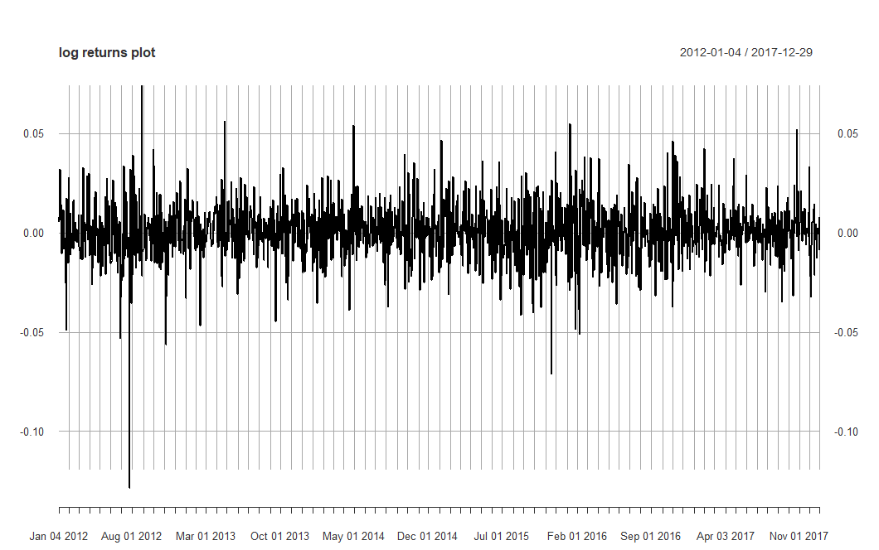
Fig.5. Logarithmic Returns Plot for Apple Inc. from Yahoo! Finance

Moving Average (MA) Models – It gives regression error as a linear combination of past error terms. The number of lagged values of the error term is denoted by the “q” value in the model.

The general equation for ARIMA can be given as-
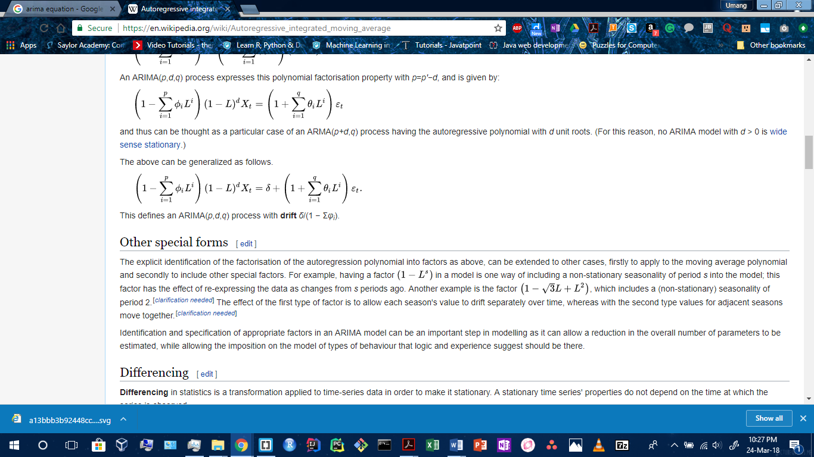
where this defines an ARIMA(p,d,q) process with drift equal to δ/(1 − Σφi).
Here, ACF plot and PACF plot [Fig. 6.] were used to give the accurate lagged values of the error term for getting “q” value. The values of “p”, “d” and “q” were adjusted automatically in each seasoned interval, for improving the accuracy of the overall prediction.
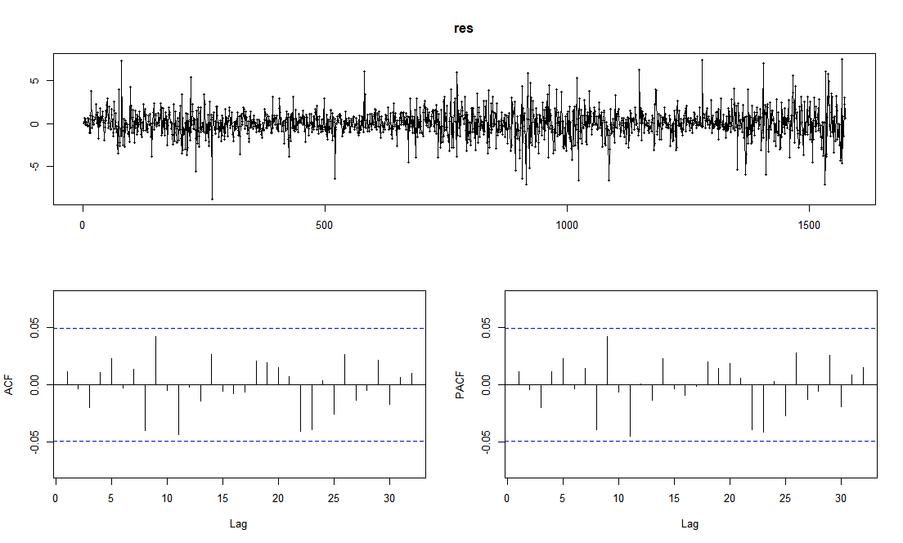
Fig.6. Residuals from Logarithmic Returns along with ACF and PACF Plots of them
After that, an extensible time series (xts) object is initialized for Actual log returns and a data frame for the forecasted return series. A loop was then run through each seasoned interval giving the forecasted interval and use HMM result to select the most likely boundary value. The Accuracy Percentage of the forecast was calculated by aggregating values in a table. The predicted stock returns for testing data [Fig. 8.] are also compared with their actual returns in the testing phase of ARIMA. The accuracy was 50 percent until here and was increased through the usage of Neural Network in the Ensemble Model.
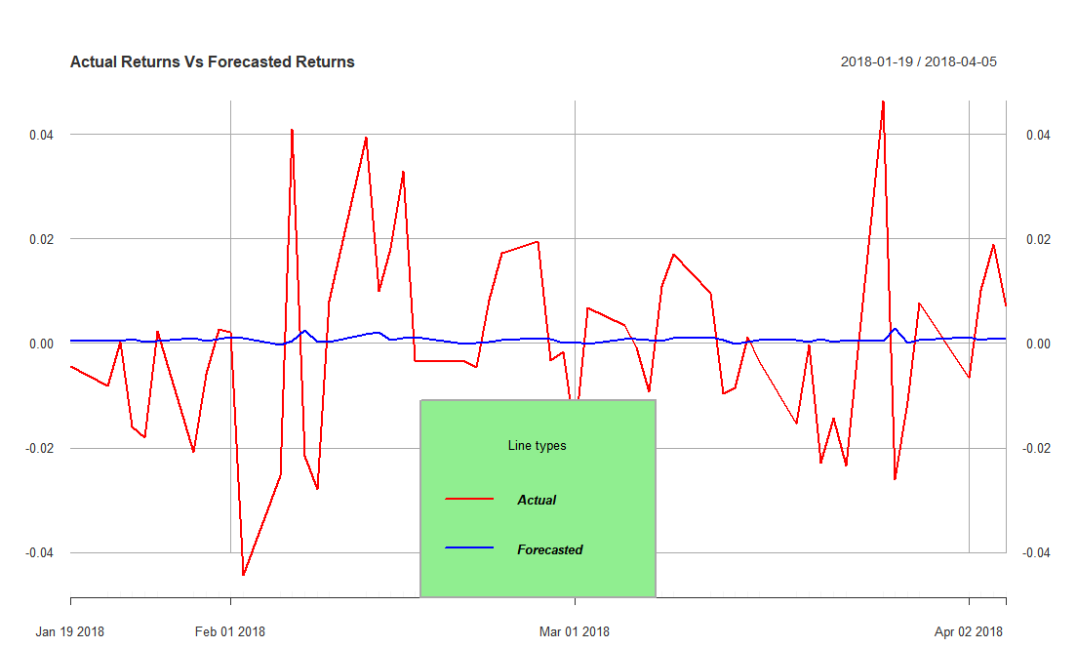
Fig.8. Actual Returns Vs Forecasted Returns for Apple Inc. from ARIMA

Neural Network

A feed-forward Neural Network was used on the logarithmic returns obtained from ARIMA through the (p,d,q) parameters passed to the Neural Network. The network was constructed with single hidden layer and number of states equal to half of the stock prices for training. The testing proved the results to be more accurate from the Ensemble of ARIMA and Neural Network to be 89 percent accurate [Fig. 9.] with very low MAPE (Mean Average Percentage Error) = 2.75 and RMSE (Root Mean Square Error) = 5.43.
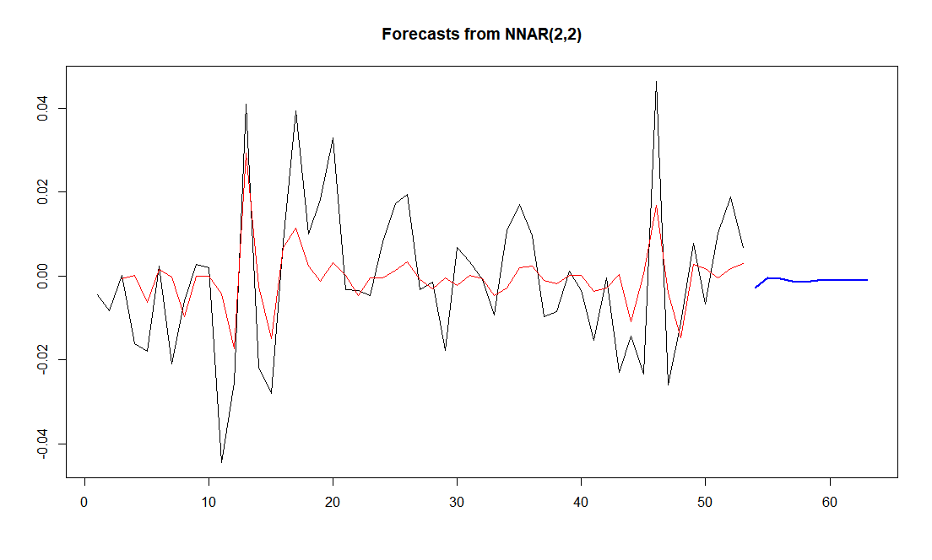
Fig.9. Actual Returns Vs Forecasted Returns for Apple Inc. from Ensemble of Neural Network and ARIMA

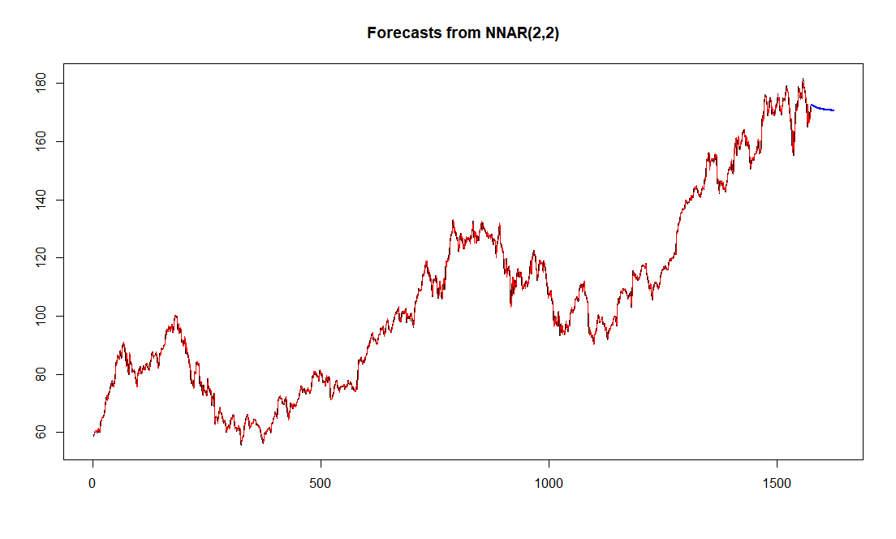
Fig.10. Closing Price of Next 50 days for Apple Inc. forecasted from the Ensemble Model

The model predicts the Closing price for next 50 days along with the logarithmic Daily change for any number of days. The results obtained predicted the market direction which was verified on the NASDAQ and forecasted Closing Price [Fig. 10.] which was very near to the actual value.

Random Walk Model
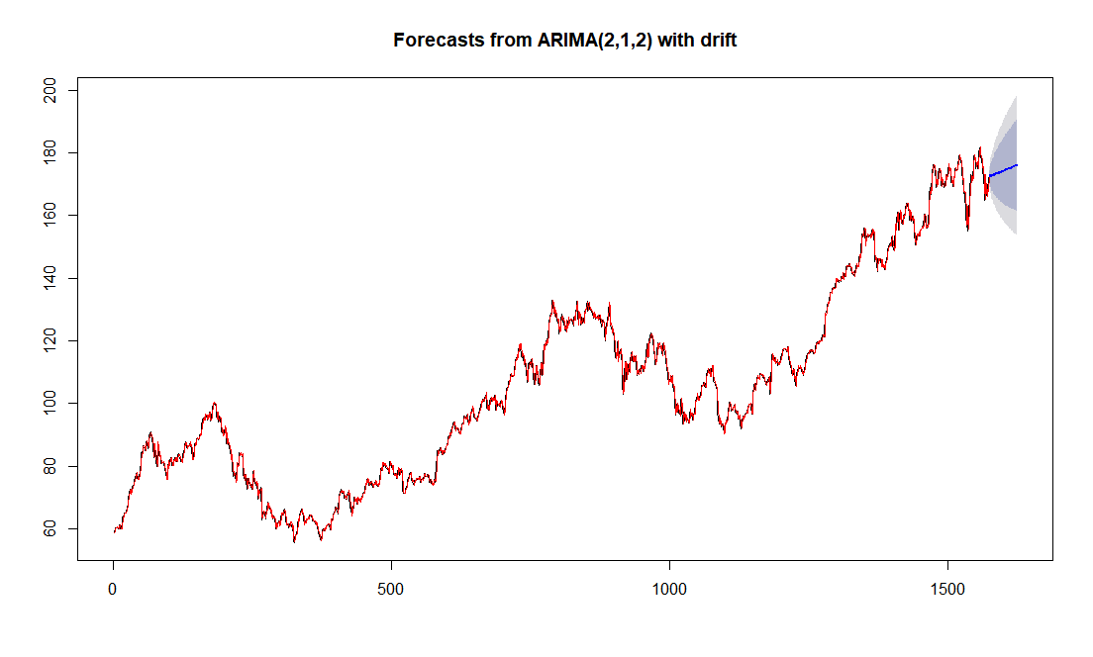
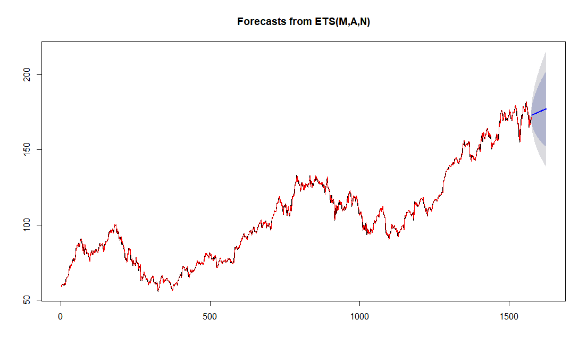
Fig.11. The Drift boundaries of ARIMA and Exponential Smoothening (ETS) predicted by Random Walk of Ensemble Model

The Random Walk Model is used in Ensemble for finding the Drift boundaries obtained [Fig. 11.] in ARIMA forecasts. It is a famous theory among financial hypotheses which says that time-series data is formed from the random or stochastic process, that consists of a series of random steps on the financial historical dataset space such as the Daily Changes. It connects the next day’s opening price to be previous day’s closing price with most likely deviation to be maximum frequency/probability of percentage change which occurred on daily basis. Through a MapReduce implementation of frequencies of past Daily changes on Hadoop framework, the most likely boundary values of percentage change for the region of 95 percent and 90 percent occurring daily is found from the Random Walk model from the historical data of past 40 years.

Conclusion

In this proposed research project, an attempt is made to develop a prediction and forecasting model for finding the future stock market movements and their values based on the sentiment analysis of opinions and emotions expressed on Twitter feeds for a healthcare industry, like Apple Inc., using opinion mining and using this correlation for time series analysis using historical stock market data, big data processing, and data preprocessing, and machine learning algorithms and techniques. The predicted outputs show the proposed model’s potential to forecast the stock market movements for the short-term analysis of future, like for the next day, helping investors in their profitable investments in securities of stock markets and decisions related to buying/selling/holding a stock share, and thereby they can also contribute to advancements in technology through investing in the best Technology industry, and compete successfully with other emerging prediction and forecasting techniques. Other industry sectors like Healthcare could also be used for investments forecasting for saving lives.

Future Works

Other opportunities for improvements, which could be done on the proposed model, include using sentiments from News sources. Also, outliers and robots can be identified by validating the people responsible for the sentiments from the past week to be humans or not.

References

- Rao, Tushar, and Saket Srivastava. “Analyzing stock market movements using twitter sentiment analysis.” In Proceedings of the 2012 International Conference on Advances in Social Networks Analysis and Mining (ASONAM 2012), pp. 119-123. IEEE Computer Society, August 2012.
- Bollen, Johan, Huina Mao, and Xiaojun Zeng. "Twitter mood predicts the stock market." Journal of computational science 2, no. 1 (2011): 1-8.
- Makrehchi, Masoud, Sameena Shah, and Wenhui Liao. "Stock prediction using event-based sentiment analysis." In Web Intelligence (WI) and Intelligent Agent Technologies (IAT), 2013 IEEE/WIC/ACM International Joint Conferences on, vol. 1, pp. 337-342. IEEE, December 2013.
- Go, Alec, Richa Bhayani, and Lei Huang. "Twitter sentiment classification using distant supervision." CS224N Project Report, Stanford 1, no. 12 (2009).
- Liu, Bing, Minqing Hu, and Junsheng Cheng. "Opinion observer: analyzing and comparing opinions on the web." In Proceedings of the 14th international conference on World Wide Web (WWW-2005), pp. 342-351. ACM, May 10-14, 2005.
- Sahni, Tapan, Chinmay Chandak, Naveen Reddy Chedeti, and Manish Singh. "Efficient Twitter sentiment classification using subjective distant supervision." In Communication Systems and Networks (COMSNETS), 2017 9th International Conference on, pp. 548-553. IEEE, June 2017.
- Angadi, Mahantesh C., and Amogh P. Kulkarni. "Time Series Data Analysis For Stock Market Prediction Using Data Mining Techniques With R." International Journal of Advanced Research in Computer Science 6, no. 6 (2015), August 2015.
- Chen, Ray, and Marius Lazer. "Sentiment analysis of twitter feeds for the prediction of stock market movement." stanford. edu. Retrieved January 25 (2013), Cs 229, pp. 15, 2013.
- Bing, Li, Keith CC Chan, and Carol Ou. "Public sentiment analysis in Twitter data for prediction of a company's stock price movements." In e-Business Engineering (ICEBE), 2014 IEEE 11th International Conference on, pp. 232-239. IEEE, 2014.
- Zhang, Linhao. "Sentiment analysis on Twitter with stock price and significant keyword correlation." Ph.D. dissertation, pp. 130, 2013.
- Dickinson, Brian, and Wei Hu. "Sentiment analysis of investor opinions on twitter." Social Networking 4, no. 03 (2015): 62..
- Mittal, Anshul, and Arpit Goel. "Stock prediction using twitter sentiment analysis." Standford University, CS229 (2011 http://cs229.stanford. edu/proj2011/GoelMittalStockMarketPredictionUsingTwitterSentimentAnalysis. pdf ) 15 (2012).
- List of Positive Words - Positive Words Research, http://positivewordsresearch.com/list-of-positive-words/.
- NASDAQ Stock Quote for Apple Inc., https://www.nasdaq.com/symbol/aapl.
- Google Finance Apple Inc.'s NYSE Quote, http://www.google.com/finance?q=NYSE:AAPL .
- Yahoo! Finance Stock Details for Apple Inc., https://finance.yahoo.com/q?s=AAPL.
- Bouktif, Salah, and Mamoun Adel Awad. "Ant colony based approach to predict stock market movement from mood collected on Twitter." In Advances in Social Networks Analysis and Mining (ASONAM), 2013 IEEE/ACM International Conference on, pp. 837-845. IEEE, 2013.
- Gunduz, Hakan, Zehra Cataltepe, and Yusuf Yaslan. "Stock market direction prediction using deep neural networks." In Signal Processing and Communications Applications Conference (SIU), 2017 25th, pp. 1-4. IEEE, 2017.
- Bautu, Elena, Andrei Bautu, and Henri Luchian. "Evolving gene expression programming classifiers for ensemble prediction of movements on the stock market." In Complex, Intelligent and Software Intensive Systems (CISIS), 2010 International Conference on, pp. 108-115. IEEE, 2010.
- Nelson, David MQ, Adriano CM Pereira, and Renato A. de Oliveira. "Stock market's price movement prediction with LSTM neural networks." In Neural Networks (IJCNN), 2017 International Joint Conference on, pp. 1419-1426. IEEE, 2017.

